Name: Nguyễn Văn Hải
Staff code: SD5975
- Setup
Before doing this assignment you need to install Azure CLI, Terraform:
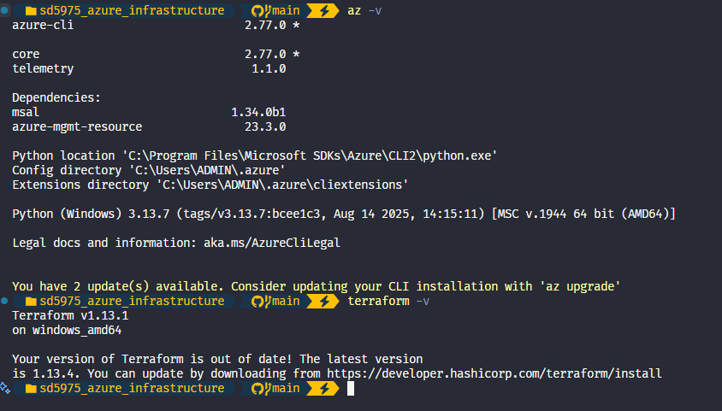
Create a subscription in Azure and login to az cli:
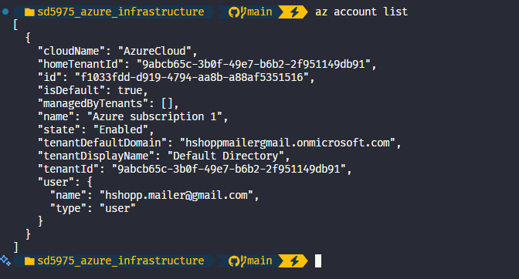
Create a Service Principal (Azure Entra ID => App Registration):
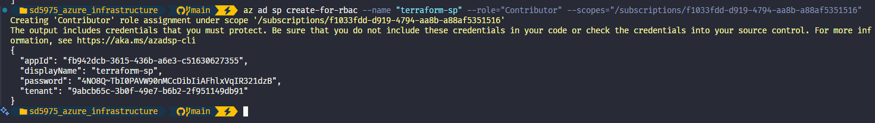
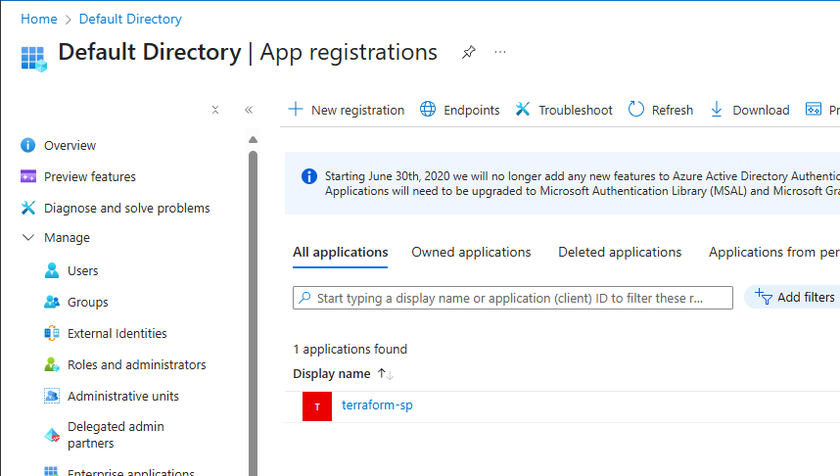

- Init terraform
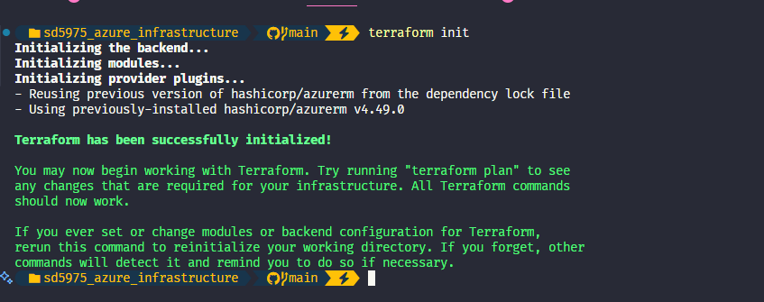
- Apply terraform
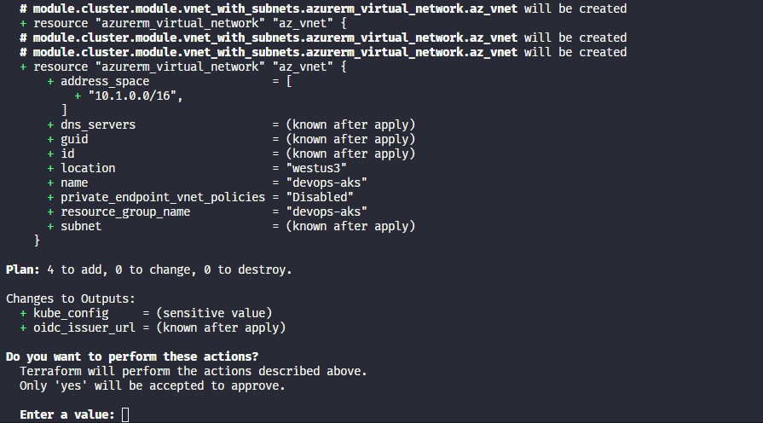
- Confirm in Azure Portal.
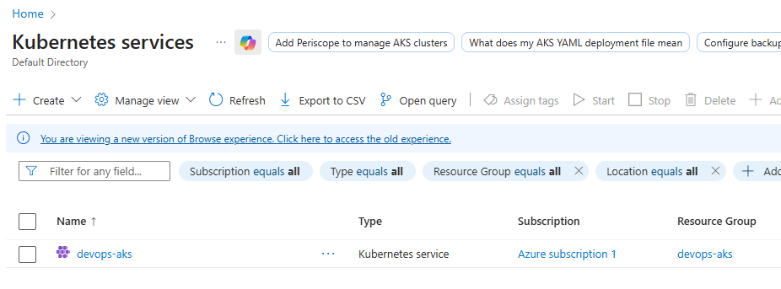
- Create ACR
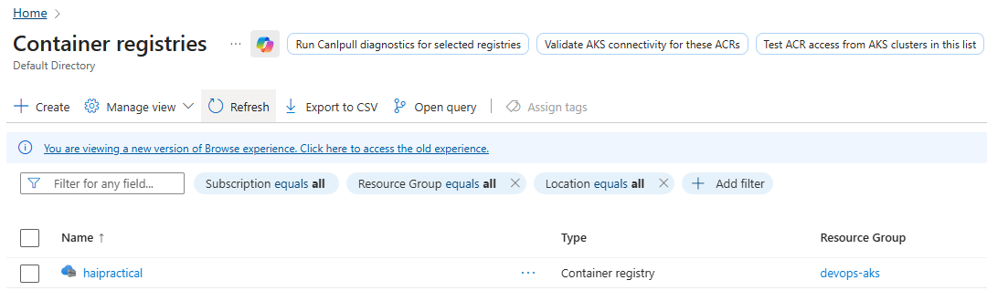
- Create SonarQube Cloud
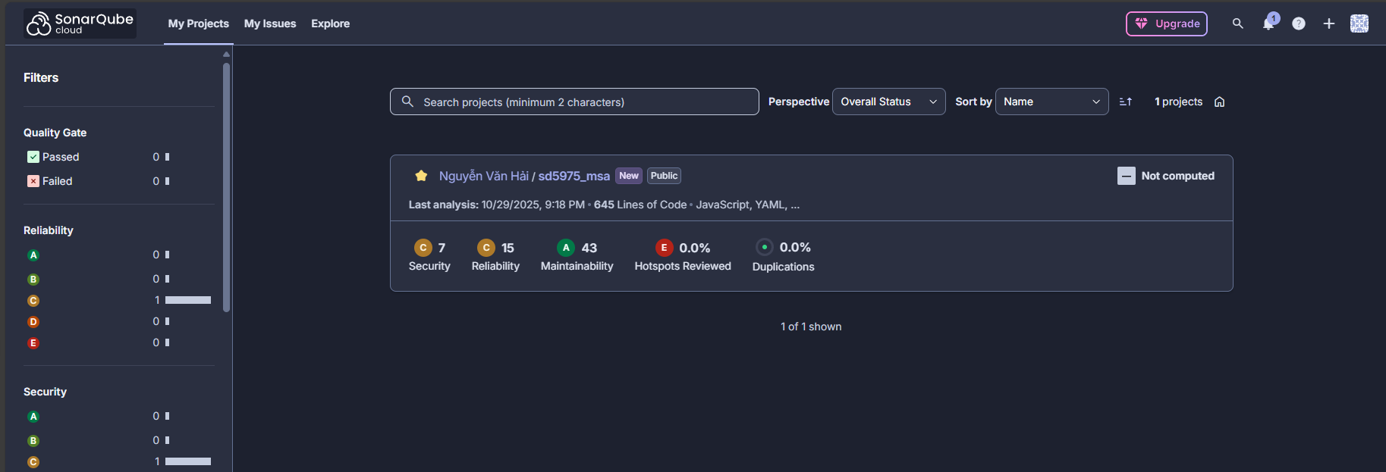
Get Project key and Information Key:
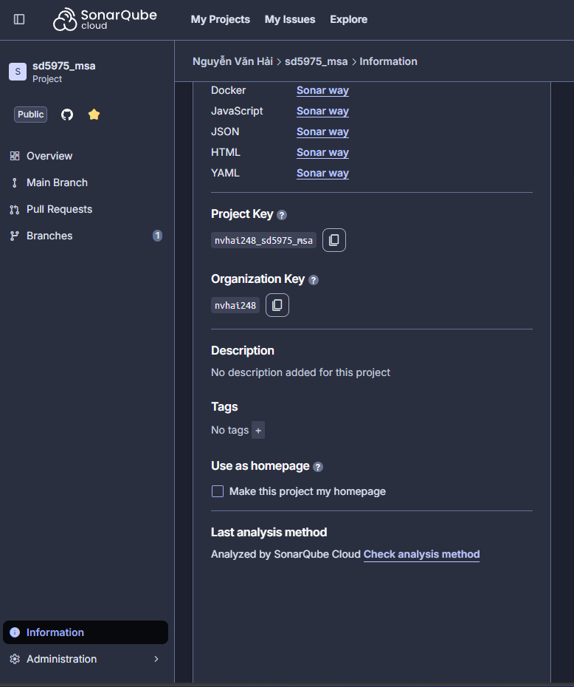
Then create a tokens for azure devops:
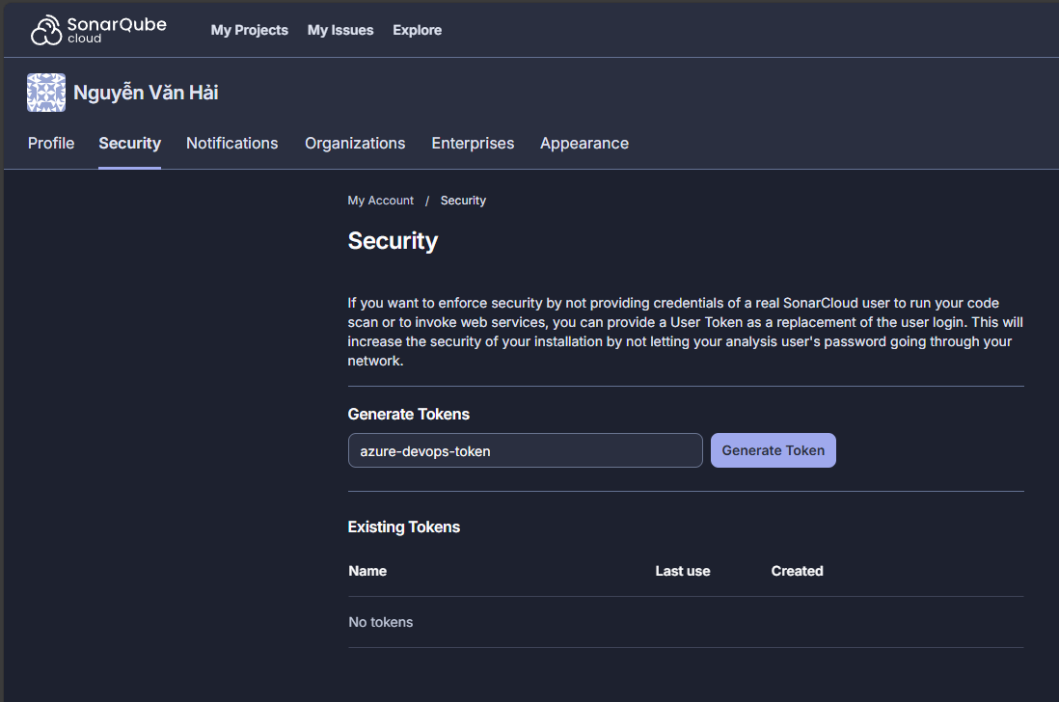
- Create Project in Azure Devops
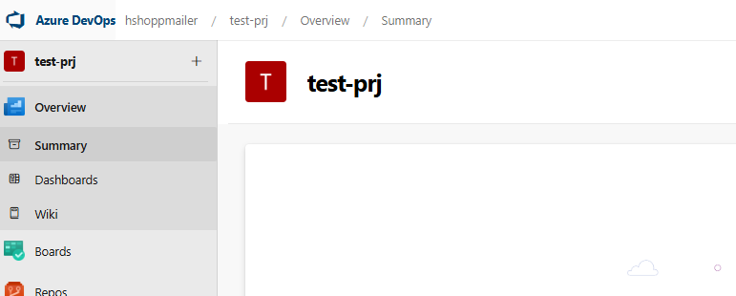
Then create Sonar cloud service connection.
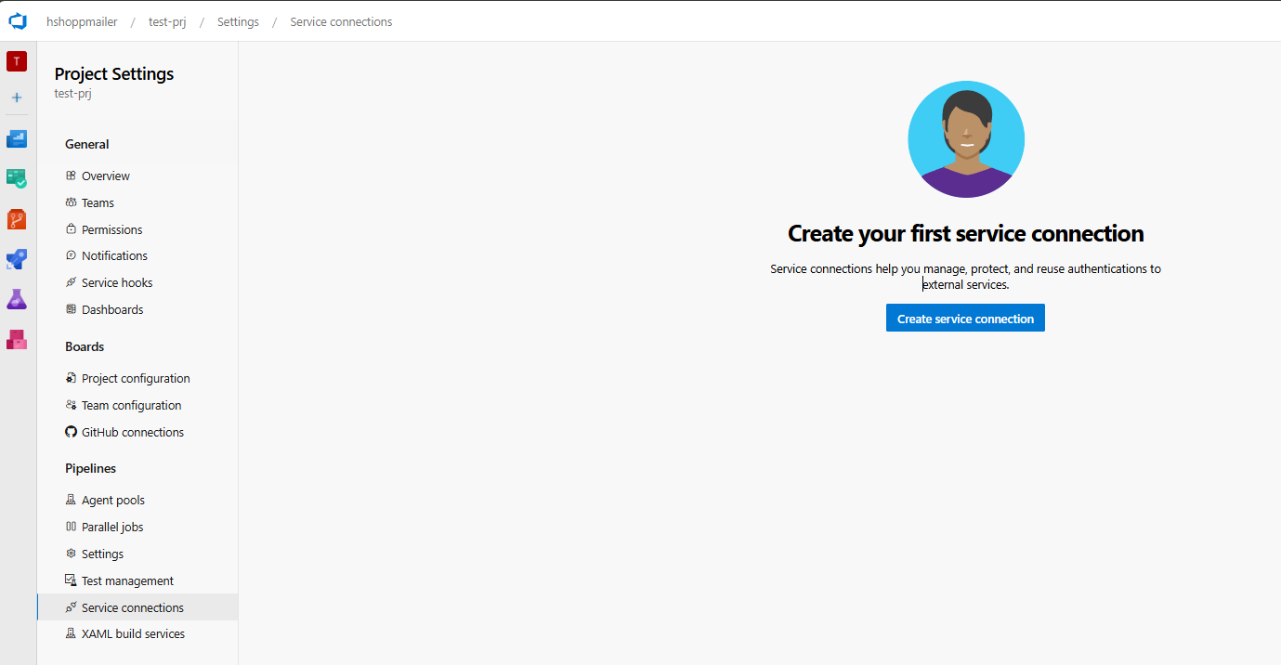
Note: Before create service connect to Sonar cloud, you must install the SonarQube or SonarCloud extension into Azure DevOps first
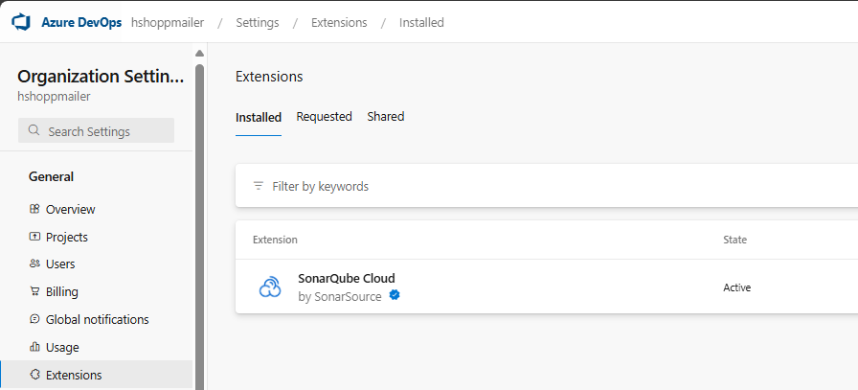
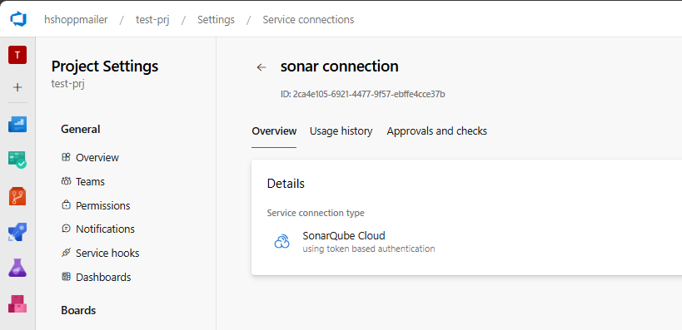
Create Environment (This step only required when deploy app to AKS)
Go to Azure DevOps > Pipelines > Environments, click Create environment

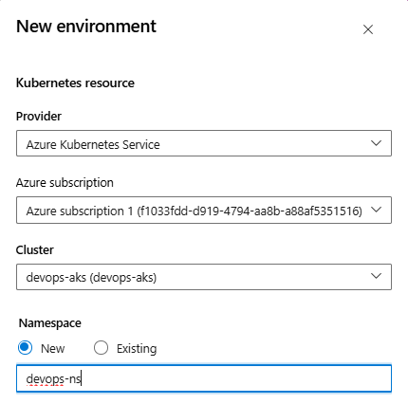
Create Azure service connection (used for AzureCLI@2 task in pipeline)
Choose Azure Resource Manager => Next
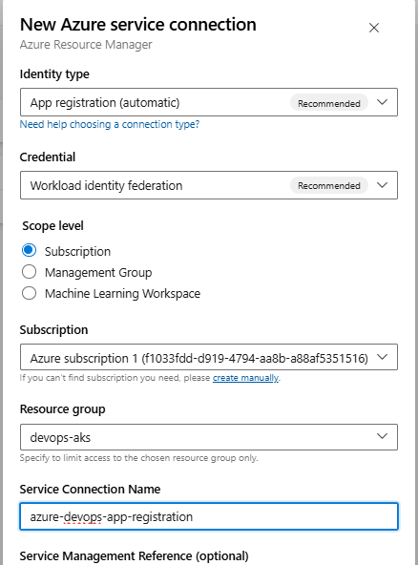
- Create Pipeline
Use github to create a pipeline (connect your github to azure devops).
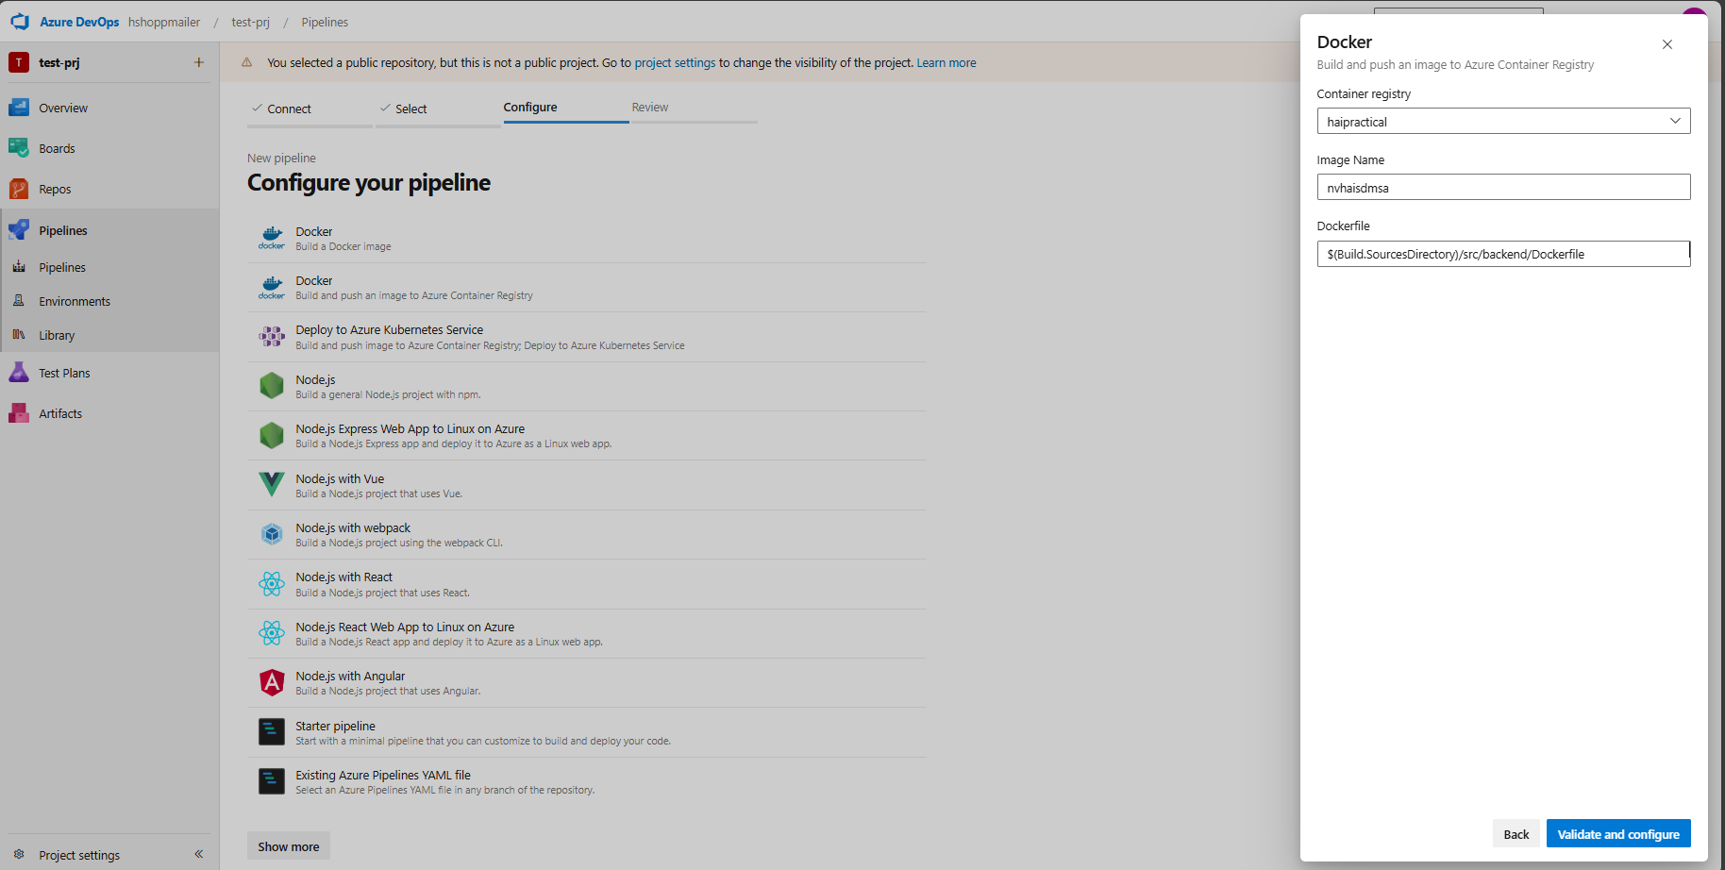
# Click Save to create azure-pipeline.yml (we will adjust this pipeline to add another step as trivy, Sonar scan)
